There are two data sets for this validation testing.  
  
The first data set will be for the average user. Going through the quiz for the first time and checking out some features.

The second data set will be only answering the questions, not using any other buttons.

The third data set will be doing everything. Not a great run academically speaking but as a demonstration that the application can handle a lot.

They’ll be labeled as Data Set 1, Data Set 2, and Data Set 3 respectively.

**DATA SET 1:**

This run will be only in full screen. This screenshot is the dialog box confirming that the user wants to go into full-screen mode.

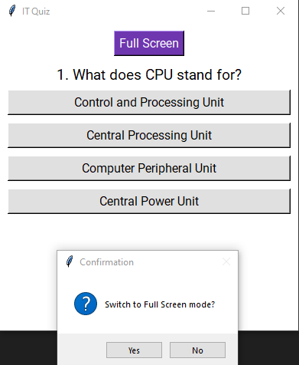

The result box comes up after selecting an answer.

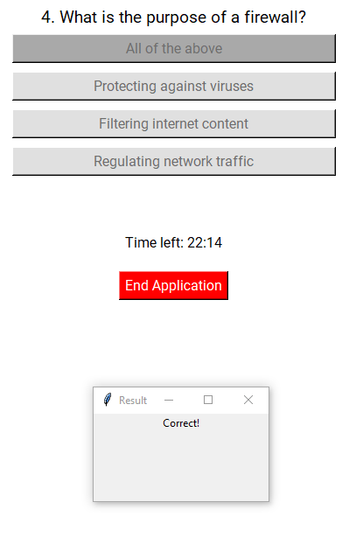

After the quiz has ended, the user is given a score along with percentage, letter grade, and the ability to view the log, restart the quiz, full screen, or end the application. (full-screen button is cut off).

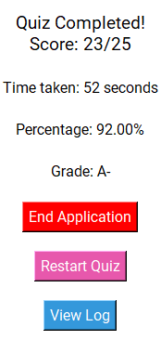

The log shows users each question, what they chose, and if they got it right or wrong  
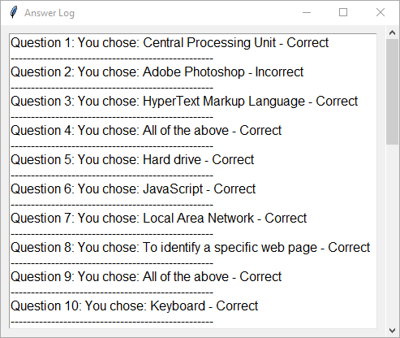

**DATA SET 2**

What it looks like without fullscreen

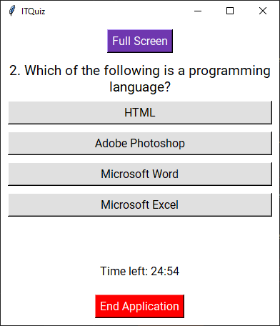

What it looks like to get a question wrong

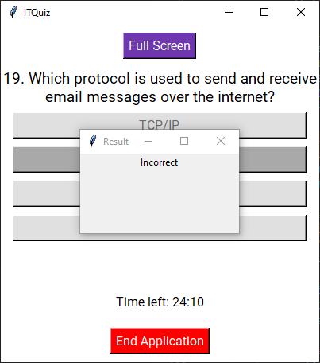

Quiz Completed screen  
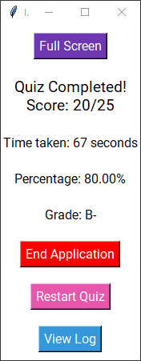

Resized both windows to show that it works well

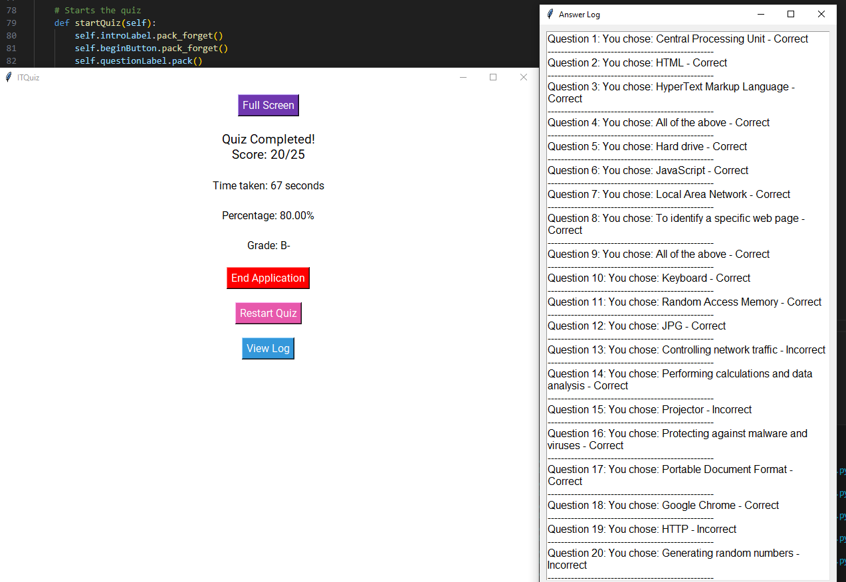

**DATA SET 3**

The beginning screen while fullscreen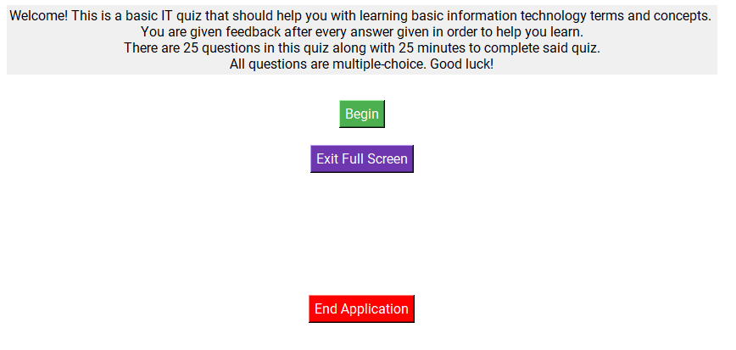

Ending screen also with the log that is halfway scrolled  
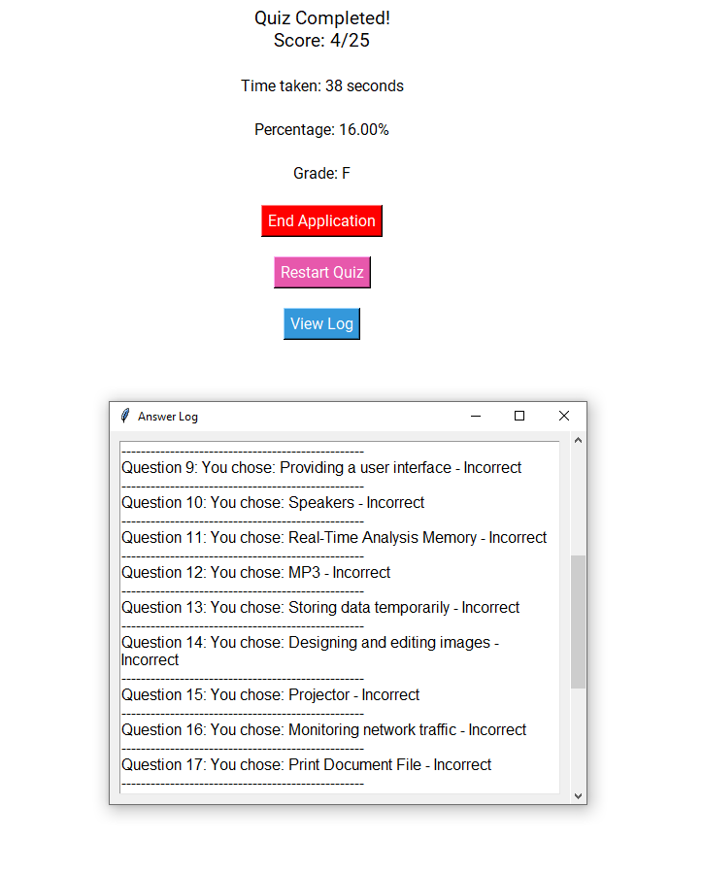

Decided to tweak the full-screen dialog box to where it specifies when it goes into windowed mode along with the “Windowed Confirmation” title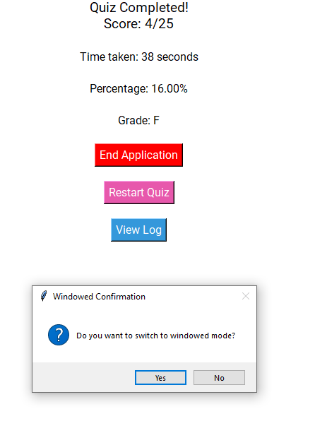

Clicked Restart Quiz

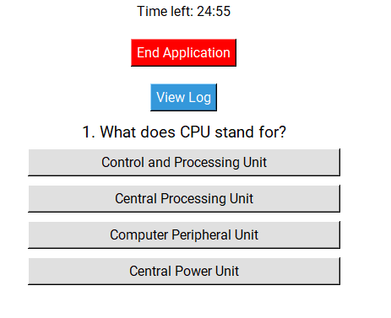

Log updates even after reset  
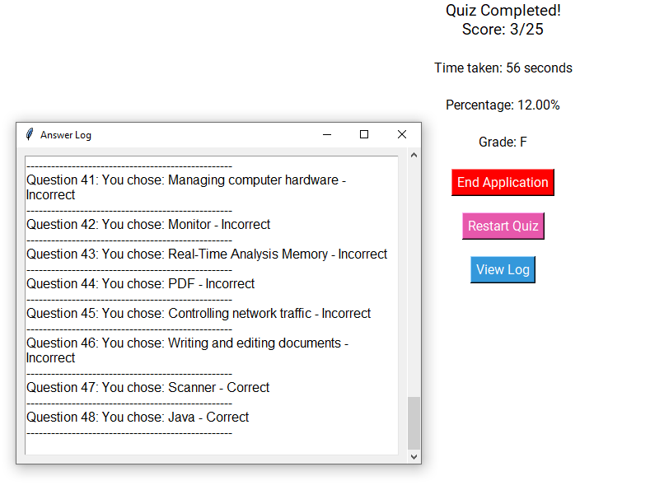

When time runs out (purposefully put the quiz at 15 seconds to speed up the process).  
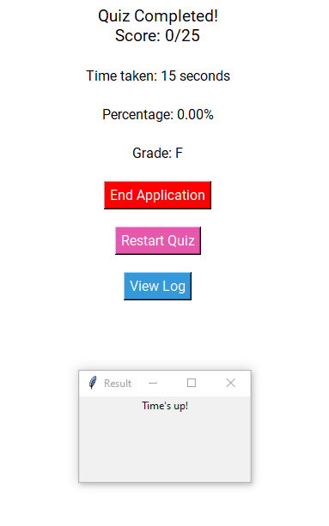

In conclusion, I made small adjustments during this validation testing. This is important for any programmer to do because it might give them ideas to help further improve their program or fix issues that went unnoticed.